My Visit to JSS Ganiyari
On one of the routine mundane days at work, when I was delivering anaesthesia in theatres, one of my surgical colleagues mentioned about Jan Swasthya Sahyog and its missions. I did not give much attention at first, putting it aside as one of many organizations in India who come up with great Ideas and land up serving their own interest. But, as the conversation progressed there were certain striking things that came out and drew my attention and compelled me into looking up their website.
The information I collated from the website www.jssbilaspur.org intrigued me more as I could relate to the people who had set out to do achieve their vision of delivering health services in the most deprived and backward part of India, with handful of resources at their disposal. Having worked in India, the memory of pain and the frustration rekindled in me – pain of not having done enough to help out in my own country and frustration of fighting the system where everything is set out for the rich and wealthy- a disparity of ever growing social, economic and healthcare services divide.
I recently visited the Hospital set up by Jan Swasthya Sahyog (JSS) in a small village called Ganiyari, about 20 km from Bilaspur town in the central state of Chattisgarh, India.
Jan Swasthya Sahyog was founded in the year 1996 by a group of like-minded health professionals during their post-graduate studies at the All-India Institute of Medical Sciences (AIIMS), New Delhi. These were a group of socialist thinkers who shared a common desire to do something to change the health situation in rural India, characterized by extreme poverty and lack of access to even the most basic care.
My point of contact was Dr.Kataria , a paediatric surgeon and one of the founder member of JSS, who lives in Bilaspur with his family around 20 km from Ganiyari. I headed straight to his house after three hours drive from Raipur airport, where I had landed earlier from Delhi. We left straight to Ganiyari village after a brief introduction in his house.
It was countryside drive out of the town into indistinct never ending deserted roads until we were accosted with few road side shops and hustle and bustle of people in the middle of the otherwise serine view of the fields all around. Our Jeep turned though the gates into a compound comprising of yellow single story buildings, lined with symmetrically planted trees. The compound was flocked by people who had travelled several kilometres — on foot, bullock carts, bus or even hitch-hiked on passing two-wheelers, trucks or tempos — to reach this institution which has come to be known as ‘JSS’. It is peopled by members of the medical fraternity who have given up lucrative practice or prestigious posts in premier institutions in India or abroad, to champion the cause of the rural poor.

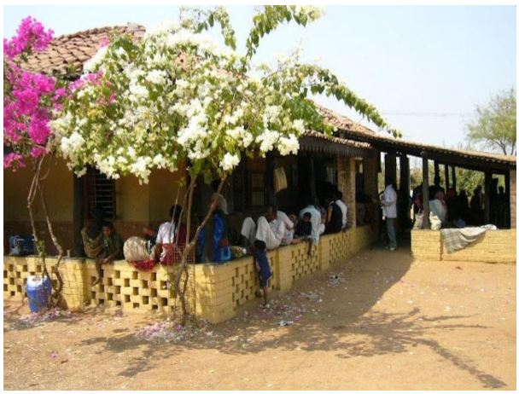
JSS OPD compound at Ganiyari
I was shown around the campus that swamped across a few acre of land- which used to be a deserted irrigation colony given by the government on long term lease. Being an anaesthetist, I was drawn to the operating theatres first. There were two large operating theatres separated by a preparation room. The infrastructure on the theatres was fairly basic to say the least. Dr Kataria was scrubbing for an elective operative case when a parent entered the operating room carrying in his arms a premature 6 weeks of girl child. The infant has a cannula in her arm. Even before the surgeon was fully gowned, the child lay on the operating table anaesthetised by his paediatrician ready for surgery. This was the case of congenital anal atresia and the procedure involved anal reconstruction and colostomy. The child was flipped over by the surgeon, caudal administered masterly and the procedure started without any hitch. I was amazed to see how they all worked as a well-oiled machine, in a remote set up as this, showing skills out of the field of expertise, yet so confidently and with immaculate safety. The theatre staff (all village residents trained by JSS) worked with great enthusiasm, vitality and positive attitude – a trait hard to witness in the best of institutions.
The cases kept coming, one after another. The list of the patients to be operated along with their specific operation was visible on the white board in the theatres. The theatre staff verified the patients, positioned them on table, inserted the cannula and administered spinal anaesthesia or dissociative anaesthesia with no fuss and delay. There were no complex pre-operative team meetings, WHO Check lists, and unnecessary delays from porters or admissions. It just worked so seamlessly uncomplicated like a brand new Rolls Roy rolling on a perfectly layered tarmac. The day ended at around 7 pm by which time nine major operations had been successfully completed in each theatre.
This was just one small snapshot of the bigger picture. The next few days I was engrossed in amazement to learn how a team of four couples from All India Institute of Medical Sciences could have come to achieve this mammoth task of not only setting up and running a tertiary hospital in the most deprived and isolated part of the country all by themselves, but also delivering a holistic primary and secondary care to a cluster of 70 tribal villages.
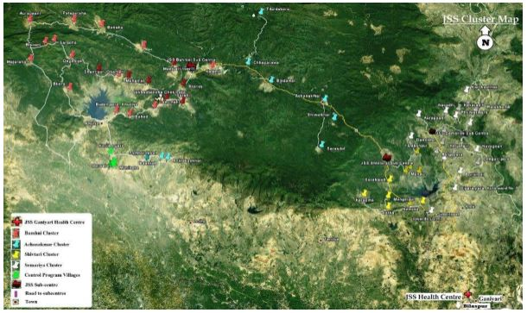
They started off by running a community based Village Health Programme, in a cluster of 8 villages which now involves swamping 70 tribal villages in four clusters in the Kota and Lormi blocks of Bilaspur district. These villages are located in forests or at the forest-fringe, and many of them lack access to all weather roads.
Their Village health models is a unique innovative three tier health care model which is run by a village health workers –the frontline force of the programme, chosen by the village community from among them, and trained and supported by JSS. At the second tier are sub-centres that support clusters of up to 20 villages each, which are manned by a team of 3 senior health workers, who again have been trained by JSS in clinical and community health skills. These in turn are supported by the referral centre at Ganiyari at the third tier.
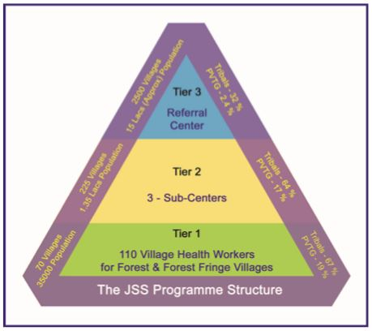
To my mind, the key element to success for running this model of care was the training of the health workers from within the village community. In areas “where there is no doctor”, people lack access to services for even the most basic of health care needs and it makes perfect sense to train Village Health Workers (VHW) in the treatment, management, and referral of a wide variety of clinical and public health problems. JSS has trained over 110 VHW and is currently reinforcing training by monthly update sessions.
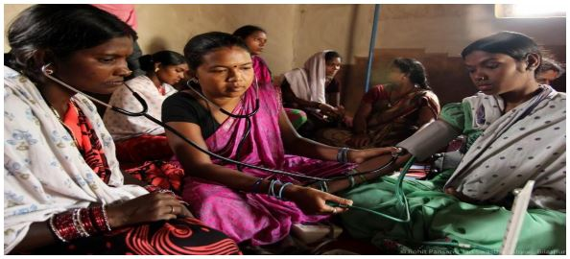

With the focus on teaching and training, a School of Nursing was set up at the Hospital site in Ganiyari which is headed by Innaciamal Jacob - a nurse educator.
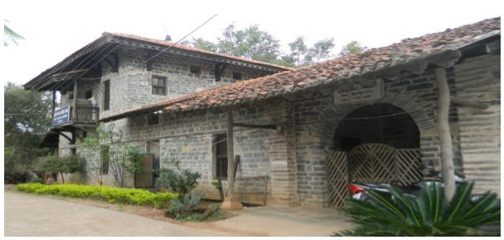
Nursing School JSS Ganiyari
The health issues in India are intricately linked with poverty and malnutrition. Under nutrition is perhaps the most widespread problem in rural Chhattisgarh, and one of the leading causes of morbidity and mortality among our patient population. The cycle of under nutrition often starts young, with consequences that can last generations.
In order to address the problem of under nutrition in children, JSS have started a “Phulwari” programme, which aims to provide a crèche facility to all children 6 months to 3 years living in any of the 54 programme villages that JSS serves. The programme supplies supplementary nutritional food and conducts activities to boost cognitive development among the children. JSS currently operates 83 Phulwari programmes, serving over 1000 children.
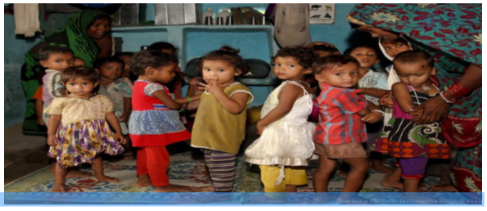
My report here is not by any way complete or holistic. There are many more aspects of JSS like us use of innovative technology, economic up-liftment of tribal villagers, management of snake bites etc which have not been described.
I am quite moved and pleased to witness the kind of dedication and selfless motive reflected by the people working at JSS Ganiyari. I have left JSS with a pledge to help out in setting up a two bedded ICU at the site. I would like to urge you to go on the website http://www.jssbilaspur.org for more information and to get involved in any way or form to help with the unfinished work.
I will end with a quote from Robert Frost:
The woods are lovely, dark and deep,
But I have promises to keep,
And miles to go before I sleep,
And miles to go before I sleep.

